**PARENT LOGIN:**

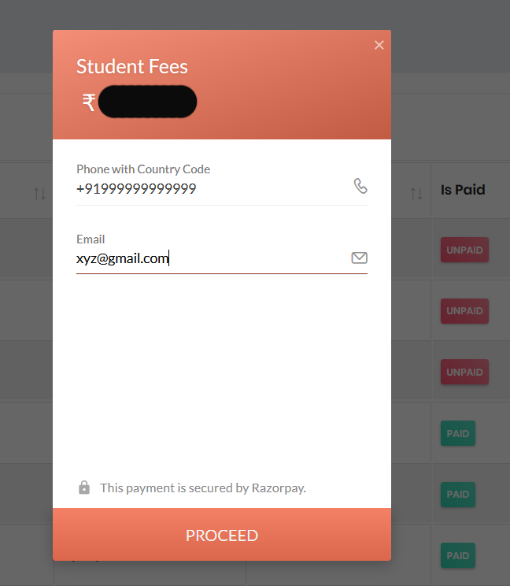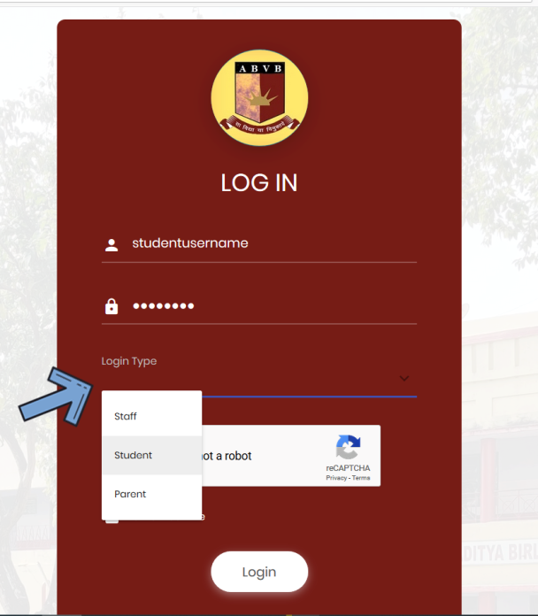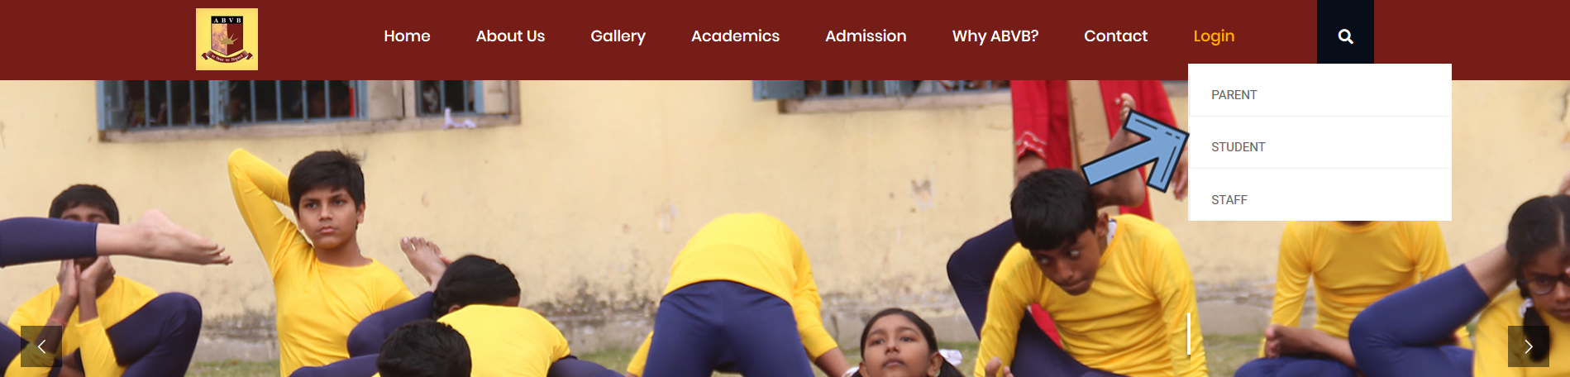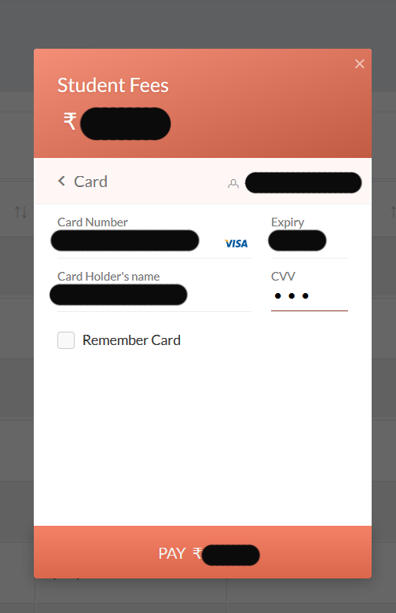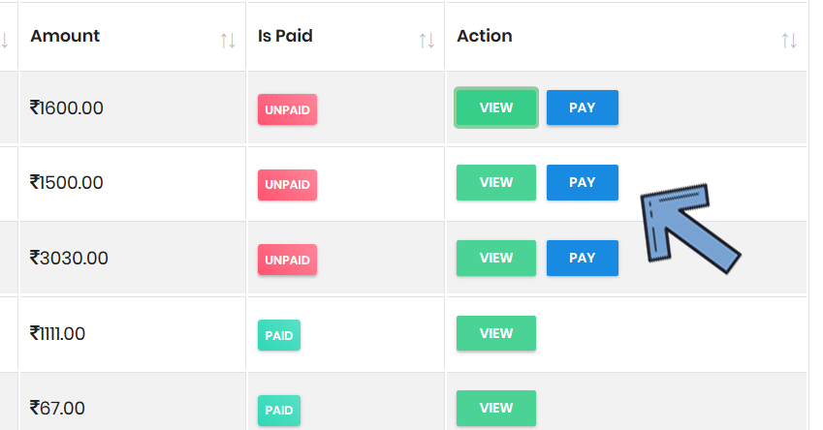

5. After entering the details, click on pay, after successful payment, your online fees will be paid.

4. Enter your details here and click proceed

3. Find the fee details of your ward, and click on Pay

2. Enter your credentials and then Select Parent here, also complete the captcha

1. From our website, click on Login and then click on parent

**STUDENT LOGIN:**

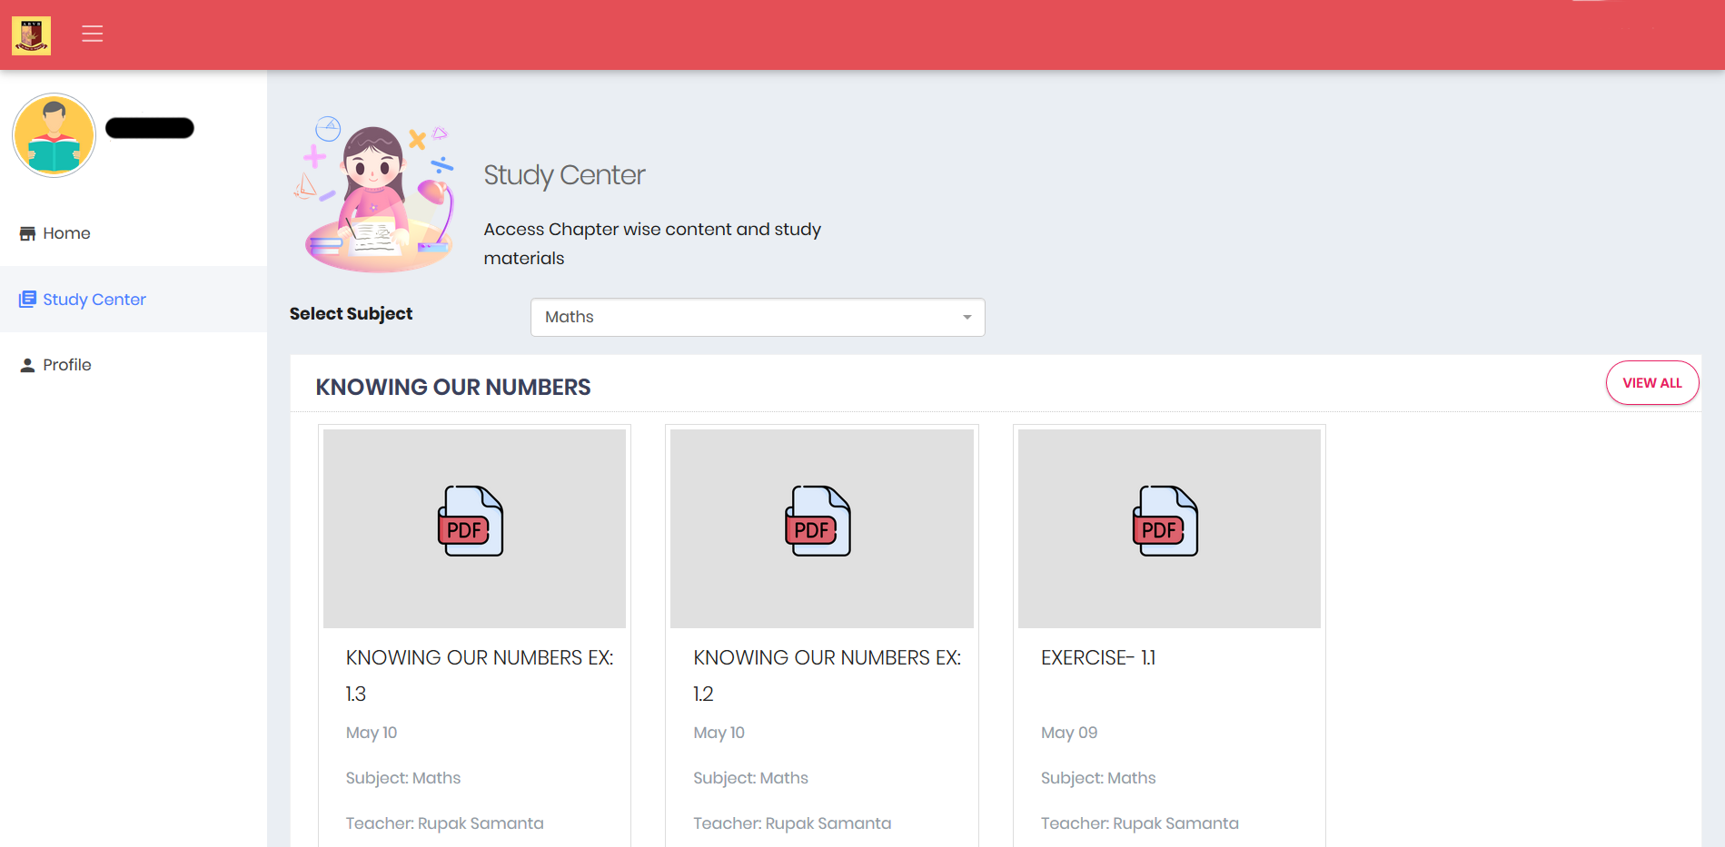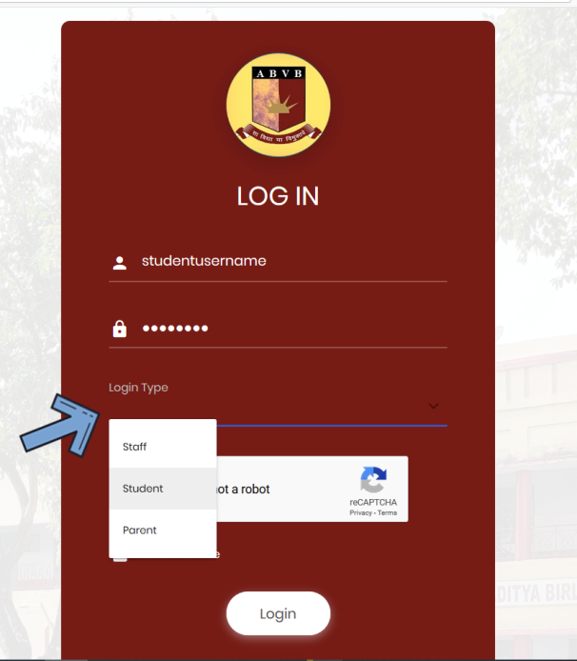

1. Once logged in, view notes/videos from your teachers from your class.

1. From our website, click on Login and then click on Student

2. Enter your credentials and then Select Student here, also complete the captcha